Proposed Change | Reason for Change
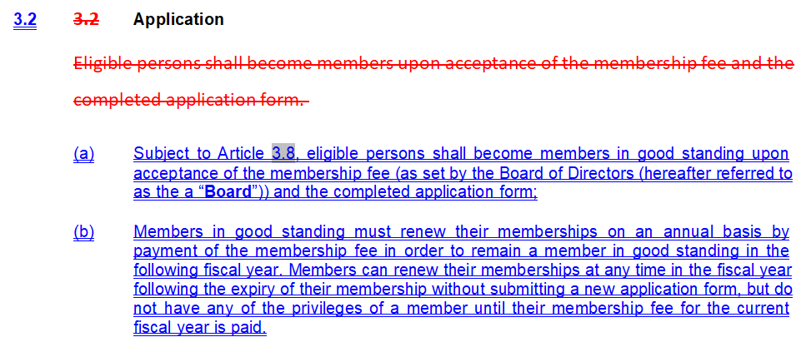 | Added clarity on membership requiring payment off dues annually.  Currently, members can let their membership “lapse” and then simply repay for another 12 month term right before they want to use a membership benefit again (ex. Boutique discount, voting at AGM, attending event). All memberships also expire on different days, adding complexity to managing who is a current member and who is not.  Changing this will streamline the membership process and hopefully improve stability of membership (necessary for proper financial budgeting).
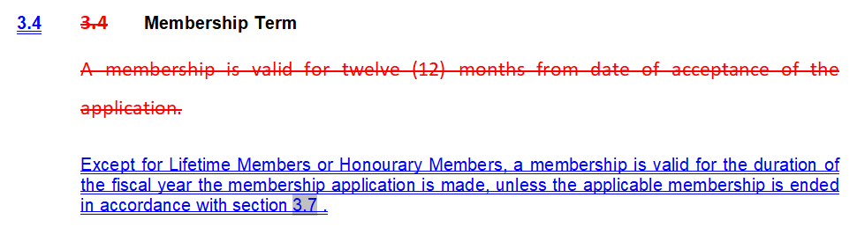 | See rationale for change to Article 3.2 above.
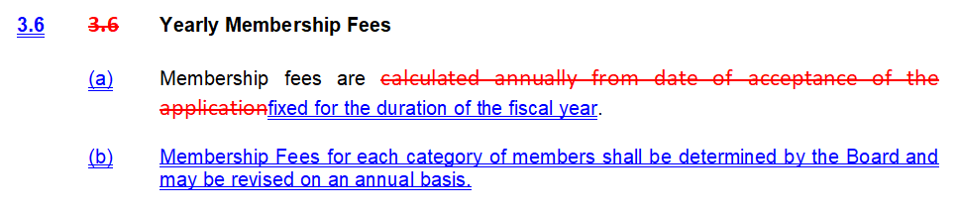 | See rationale for change to Article 3.2 above.
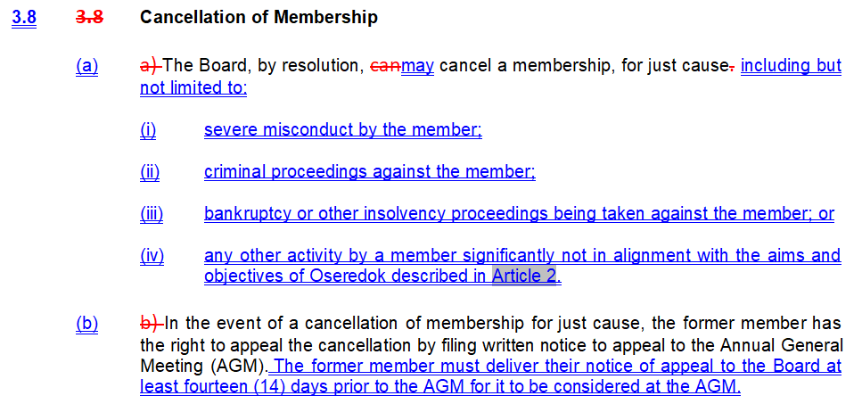 | Previously, the only parameter for cancelling a membership was for “just cause”.  This change is made to give clarity to what situation the Board may resolve to cancel a membership.  Added a process for notice of an appeal to allow AGM team time to prepare for cancellation related discussion at AGM.
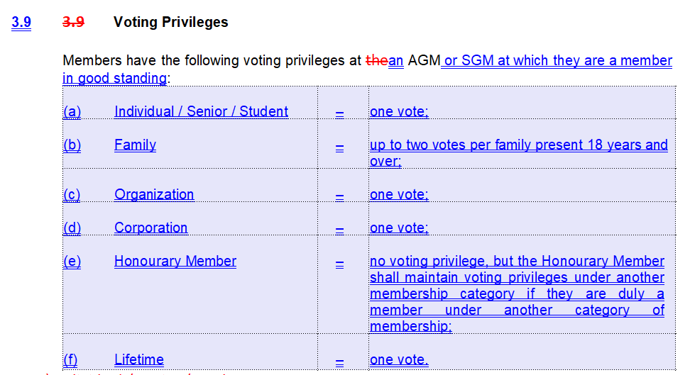 | First change is to align with more clarity over membership being in good standing for voting privileges.  Second change is to clarify that Honourary Membership does not include a voting right in and of itself (no change from before), but that an Honourary Member could also have a membership with voting privilege.
 | Fiscal year change is made to give effect to the annual membership changes, with flexibility for board to change in the future.
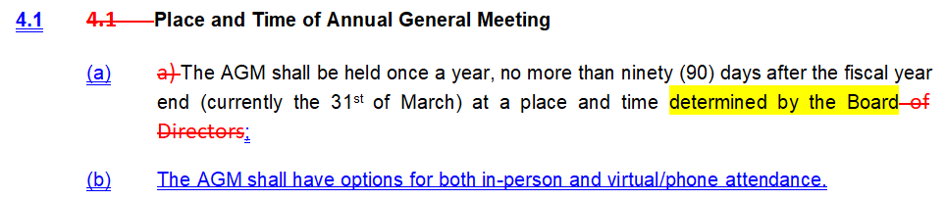 | Clarify that AGM should have in-person and virtual/phone options.
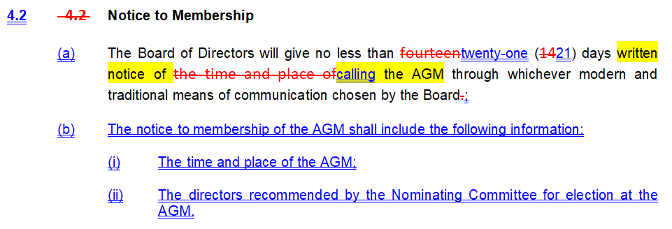 | Extended time for notice of meeting and also clarified minimum contents for the notice to membership.
 | Increased the quorum so that a minimum of 25 members must be in attendance (unless membership drops below 250 memberships, in which case the old minimum of 12 could apply).
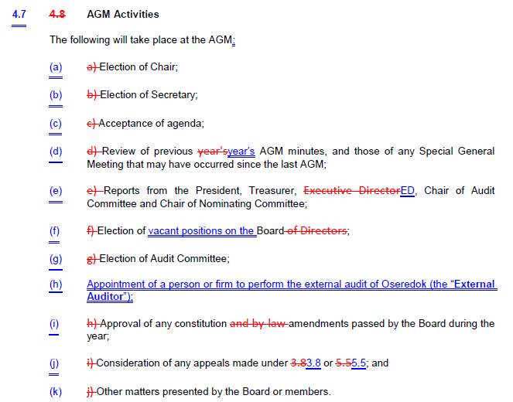 | Clarification of activities at AGM that only vacant positions are elected and the External Auditor needs to be appointed.
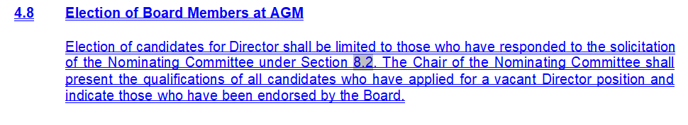  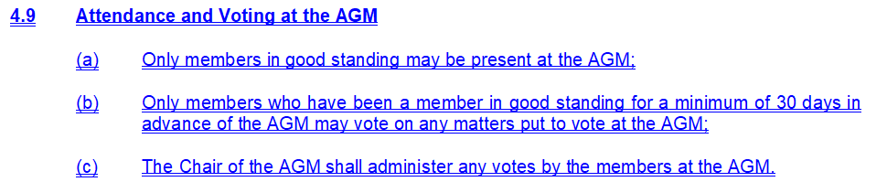 | Clarified how board members are to be elected to streamline elections at Board meetings only to those who have identified by or to the Nominating Committee.  Clarified process related rules on voting, particularly to avoid potential for a flood of new memberships at or immediately before the AGM.
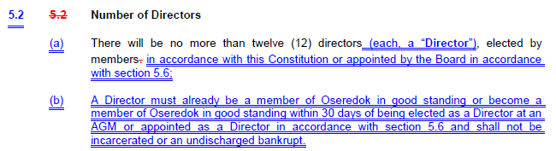 | Clarified that Directors must be members (was already implied by Directors being able to be removed for non-payment of dues).  Clarified that Directors cannot be incarcerated or bankrupt.
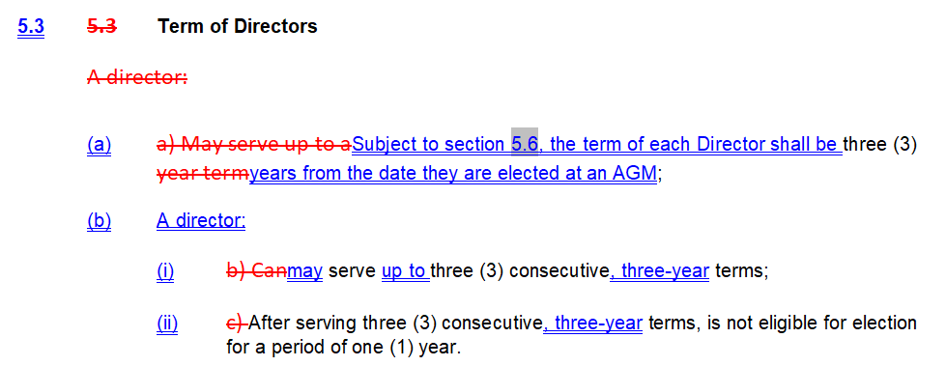 | Clarified wording on term limits, no substantive change.
 | Clarified that removal of a Director by the rest of the Board must be carried by a higher amount than 50%+1 majority.
 | Clarified process on appointment of a director to a vacant director seat. Change is not intended to be substantive.
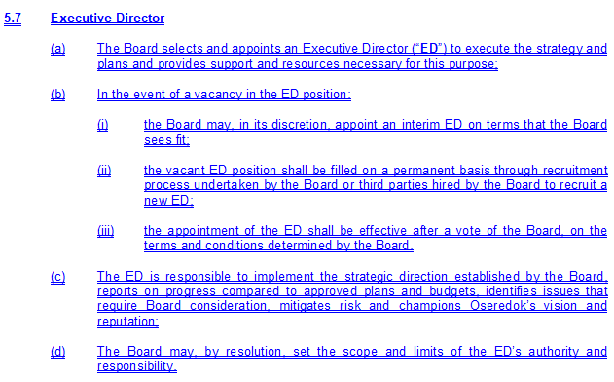 | Added clarification/direction on Board obligations in the event of a vacancy in the ED position.  Added ability for Board, by resolution, to establish limitations on the roles and responsibilities of the ED.
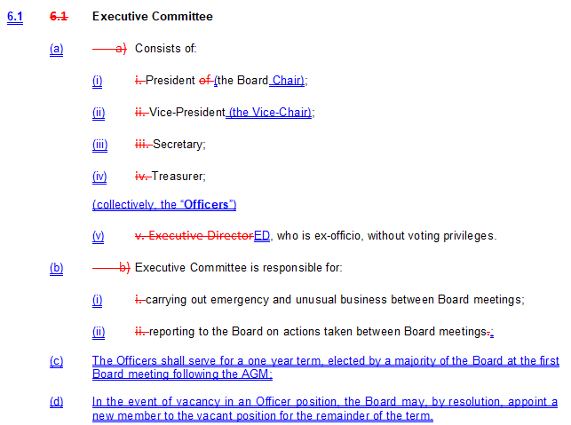 | Added definition of Officers to improve readability.  Clarified the election of Officers and process to replace vacant Officer positions.
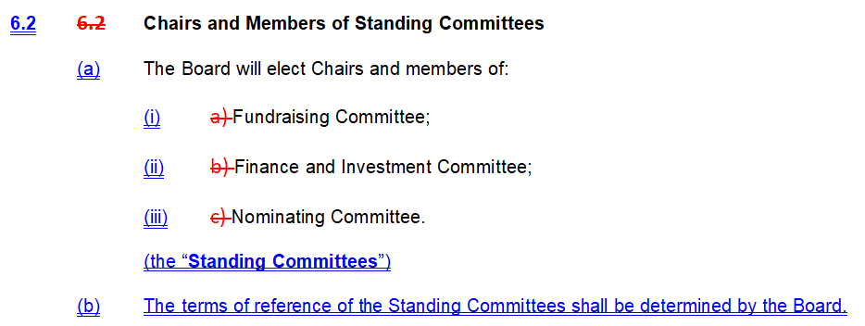 | Added definition of Standing Committees to differentiate from other ad-hoc committees created by the Board.  Clarified that the Board sets the terms of reference for the committees.
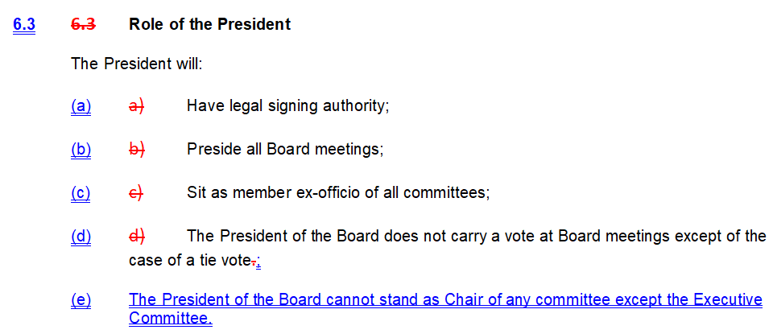 | Clarified the President is not expected to Chair any Committee.
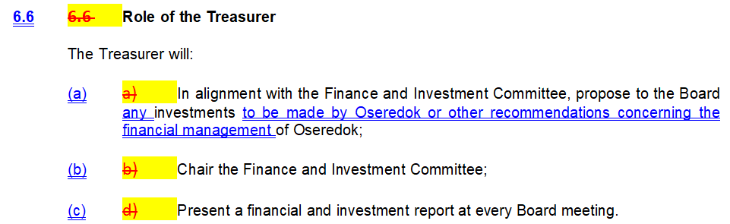 | Clarified that the Treasurer shall make recommendations on financial matters to the Board.
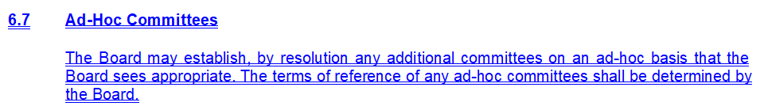 | Clarified Board’s ability to create ad-hoc committees.
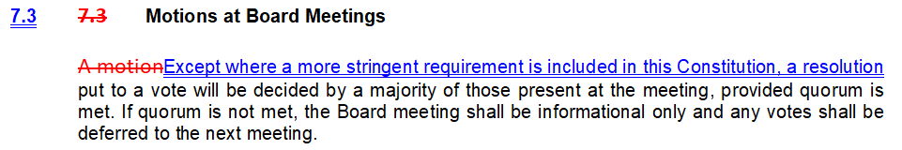 | Change related to increased threshold for removal of a Director by the Board.
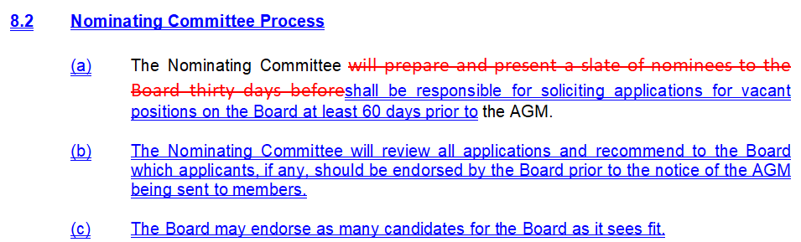 | Establishment of more defined requirements for Nominating Committee.  Since Terms of Reference are created by the Board, this section has been renamed.
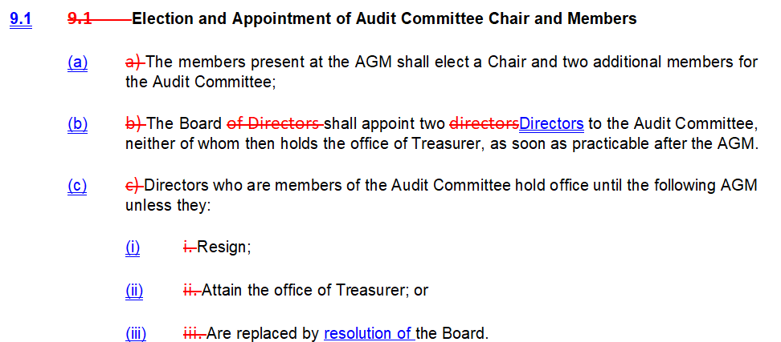 | Minor revisions.
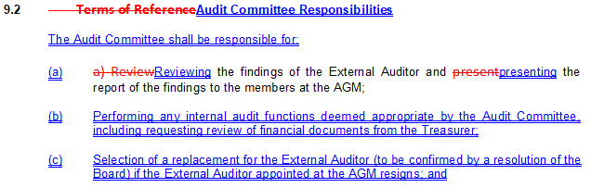  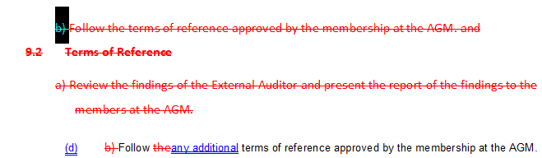 | Removal of duplication, renaming to “Responsibilities”.  Confirming that Audit Committee can, in addition to retaining external auditor, perform its own audit functions as deemed appropriate. This allows the Audit Committee, if necessary, to review the financial management of Oseredok between AGMs.  Allows Audit Committee to select a replacement External Auditor in the event that the External Auditor appointed at the AGM resigns (subject to Board approval). This allows the work to continue uninterrupted in the event of a necessary change to the auditor.
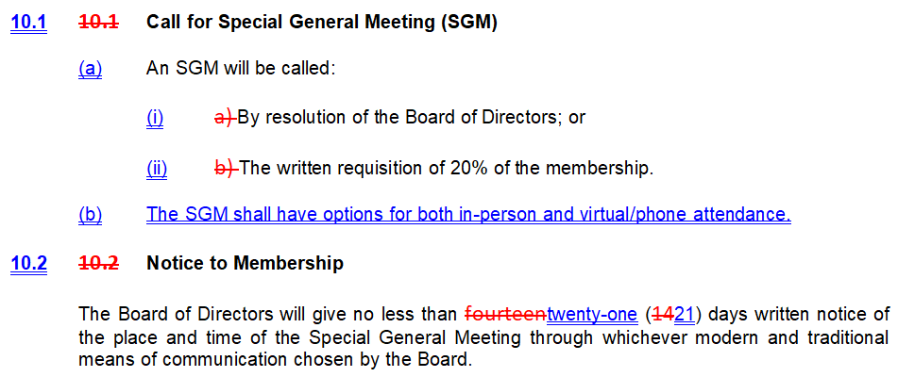 | Alignment with proposed changes to AGMs.
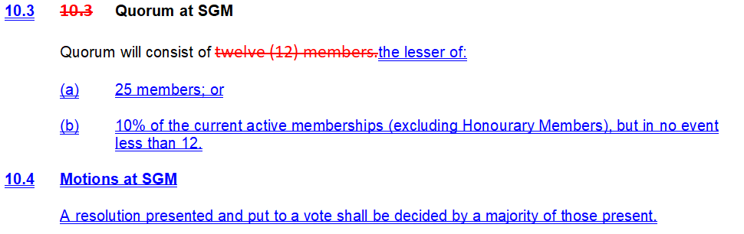 | Clarified what activities can be undertaken at an SGM to establish when an SGM can/should be used.  Added similar motion language from AGM.
  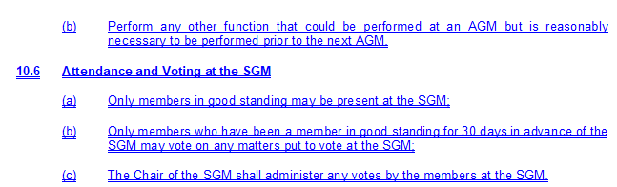 | Voting process added to align with proposed changes to AGM voting process.
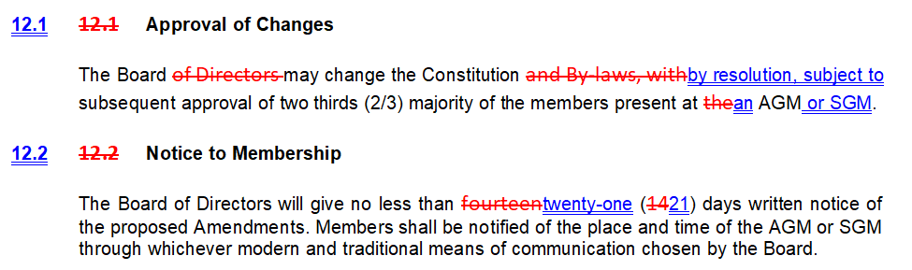 | Clarification that any Board resolutions to change the constitution do not become effective until they are approved at an AGM or SGM. SGM addition is to align with 12.2, which already contemplated that a constitutional amendment might be put forward at an SGM.  Notice requirement aligned with elsewhere.
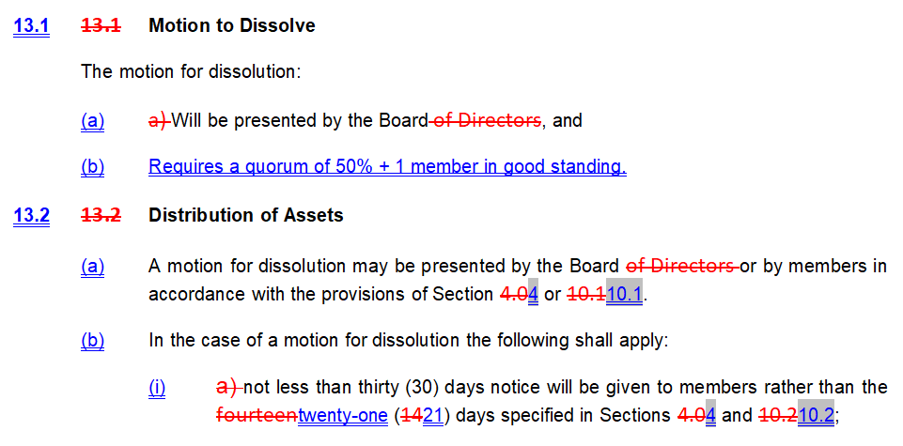 | Changes to align with notice requirements.  Increased the quorum for a Dissolution, as 12 members (as previously required at an AGM or SGM) was far too low as a baseline.

